GB_Resources Page_MVP_Plan_v5

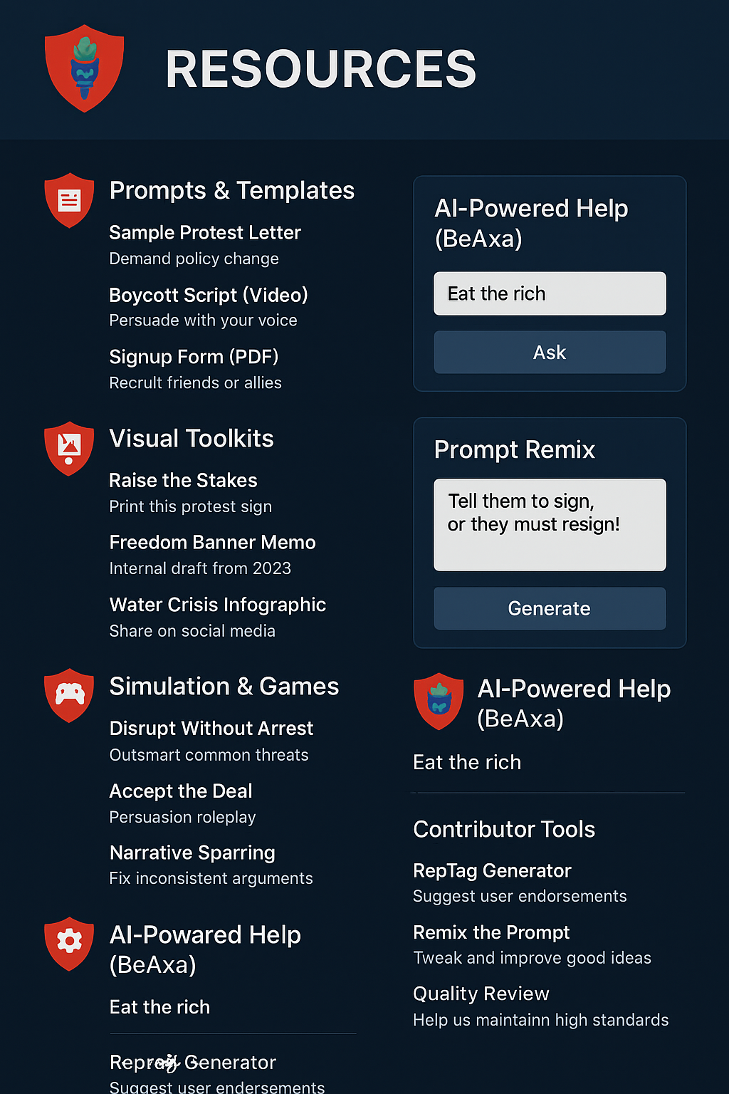
1. Structure (AnonID login)
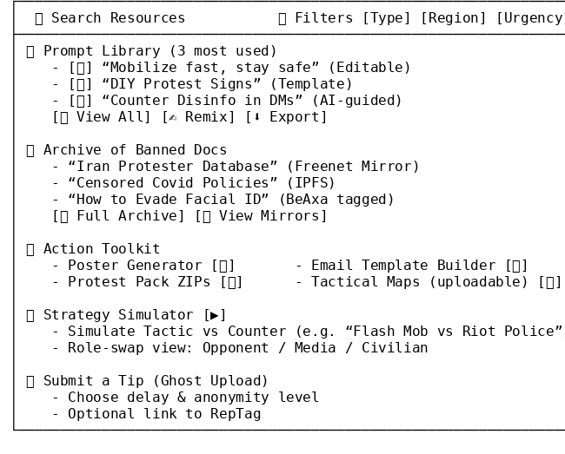

3. UX Rules (no login)

Category | Description | Popular Examples
Prompts & Templates | Editable instructions for civic engagement | Protest Letters, Boycott Campaigns, Rally Signup Sheets
Visual Toolkits | Print/post items for field use | Sign Templates, Protest Infographics, Flyers
Archives | Backup censor-risk documents | Whistleblower Leaks, Declassified Docs, Alt-history Sources
Simulation & Games | Tactic/Strategy play-testing | “Disrupt Without Arrest” roleplay, Narrative Debate Drill
AI-Powered Help | BeAxa, GenAI mod, help desk | Ask-Me-Anything, Common Challenges Explainer
Contributor Tools | Prompt editors, RepTag author | Remix Prompt, Rate Usefulness, Submit Review

3. UX Rules (no login)
Feature | Guest | AnonID | Admin/SiteMod
View Resources | ✅ | ✅ | ✅
Copy/Download | ✅ | ✅ | ✅
Submit Ghost Uploads | ❌ | ✅ | ✅
Rate or Tag Assets | ❌ | ✅ | ✅
Use Strategy Simulator | ❌ | ✅ | ✅
Fork or Remix Prompts | ❌ | ✅ | ✅
Save Work for Later | ❌ | ❌ | ✅

5. Asset Categories (no login)

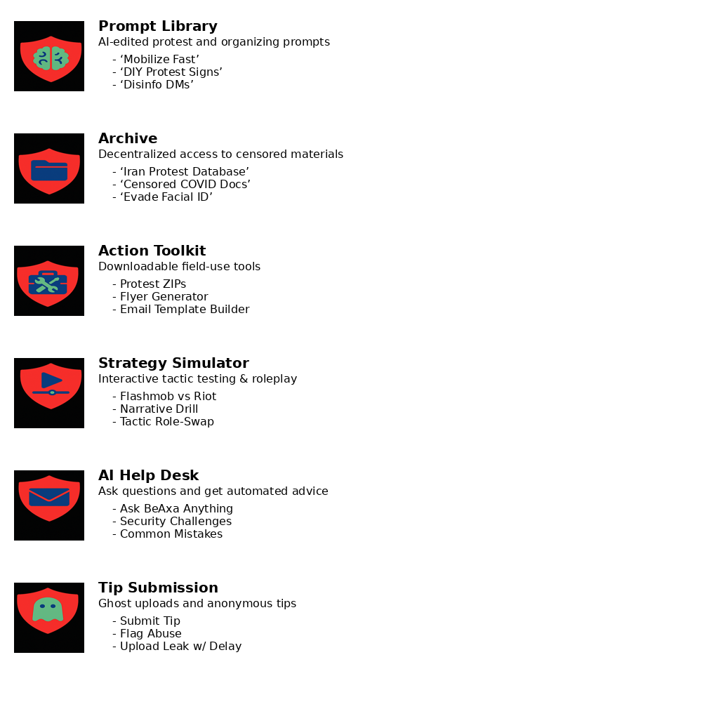
4. Branding
- BeAxaTorch logo icon appears subtly in corner of all web pages and Resource library assets.
- Other icons on red shields must be context-specific (e.g. 📂 for Archive, 🧰 for Toolkit).
- “GroupBuild” name never appears outside landing page, formal titles or headers.

5. Implementation
- Prompt Library and remix tools can be implemented as markdown templates with embedded AI-editable fields. Use OpenAI function calls or Claude API endpoints to allow template refactoring.
- Search and Filter API: consider ElasticSearch or Meilisearch for text/metadata indexing across prompt text, asset tags, and user-submitted tips.
- Archive & Ghost Uploads: IPFS + Arweave (or Filecoin) for persistent links. Add Freenet mirror support?
- Tip Submission: Use time-delayed blob storage buckets (e.g. AWS S3 or Temporal.io) with user-defined TTL, tagged by RepTag UUID.
- RepTag Voting Overlay: integrate with MeritRank backend; display public reputation weights of contributors above their asset contributions.
- Frontend: Vue 3 or React preferred. Use Tailwind CSS for clean layout and hover effects. Consider Vue transitions for tabbed content (e.g. toggle between Prompt, Archive, Simulator).

